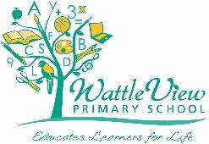
Wattle View Primary School
Child Safety and Wellbeing Policy
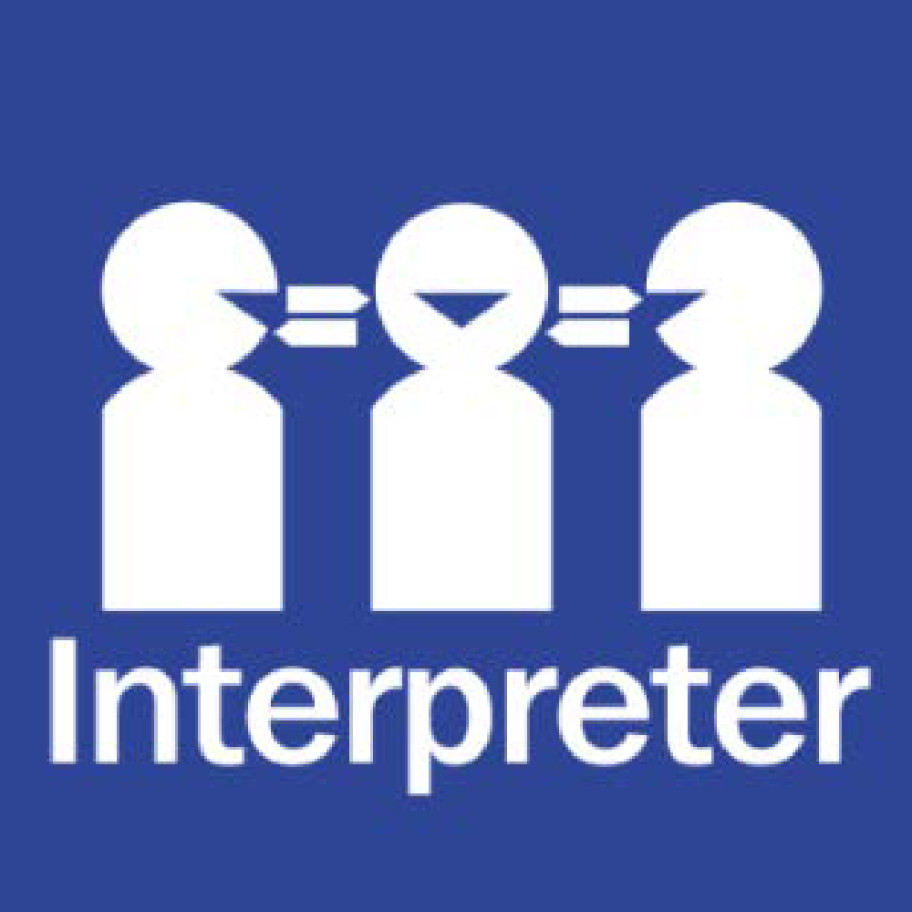
Help for non-English speakers
If you need help to understand this policy, please contact the office on 03 9758 4322

Purpose
The Wattle View Primary School Child Safety and Wellbeing Policy demonstrates our school’s commitment to creating and maintaining a child safe and child-friendly organisation, where children and young people are safe and feel safe.
This policy provides an overview of our school’s approach to implementing Ministerial Order 1359 (PDF, 363KB) which sets out how the Victorian Child Safe Standards apply in school environments.
It informs our school community of everyone’s obligations to act safely and appropriately towards children and guides our processes and practices for the safety and wellbeing of students across all areas of our work.

Scope
This policy:
- applies to all school staff, volunteers and contractors whether or not they work in direct contact with students. It also applies to school council members where indicated.
- applies in all physical and online school environments used by students during or outside of school hours, including other locations provided by for a student’s use (for example, a school camp) and those provided through third-party providers
- should be read together with our other child safety and wellbeing policies, procedures, and codes – refer to the related school policies section below.

Definitions
The following terms in this policy have specific definitions:
- child
- child safety
- child abuse
- child-connected work
- child-related work
- school environment
- school boarding environment
- school staff
- school boarding premises staff
- school governing authority
- school boarding premises governing authority
- student
- volunteer.

Statement of commitment to child safety
Wattle View Primary School is a child safe organisation which welcomes all children, young people and their families.
We are committed to providing environments where our students are safe and feel safe, where their participation is valued, their views respected, and their voices are heard about decisions that affect their lives. Our child safe policies, strategies and practices are inclusive of the needs of all children and students.
We have no tolerance for child abuse and take proactive steps to identify and manage any risks of harm to students in our school environments.
We promote positive relationships between students and adults and between students and their peers. These relationships are based on trust and respect.
We take proactive steps to identify and manage any risk of harm to students in our school environment. When child safety concerns are raised or identified, we treat these seriously and respond promptly and thoroughly.
Particular attention is given to the child safety needs of Aboriginal students, those from culturally and linguistically diverse backgrounds, international students, students with disabilities, those unable to live at home, children and young people who identify as lesbian, gay, bisexual, trans and gender diverse, intersex and queer (LGBTIQ+) and other students experiencing risk or vulnerability. Inappropriate or harmful behaviour targeting students based on these or other characteristics, such as racism or homophobia, are not tolerated at our school, and any instances identified will be addressed with appropriate consequences.
Child safety is a shared responsibility. Every person involved in our school has an important role in promoting child safety and wellbeing and promptly raising any issues or concerns about a child’s safety. We are committed to regularly reviewing our child safe practices, and seeking input from our students, families, staff, and volunteers to inform our ongoing strategies.

Roles and responsibilities
School leadership team
Our school leadership team (comprising the principal, assistant principal and teacher specialists) is responsible for ensuring that a strong child safe culture is created and maintained, and that policies and practices are effectively developed and implemented in accordance with Ministerial Order 1359.
Principals and assistant principals will:
- ensure effective child safety and wellbeing governance, policies, procedures, codes and practices are in place and followed
- model a child safe culture that facilitates the active participation of students, families and staff in promoting and improving child safety, cultural safety and wellbeing
- enable inclusive practices where the diverse needs of all students are considered
- reinforce high standards of respectful behaviour between students and adults, and between students
- promote regular open discussion on child safety issues within the school community including at leadership team meetings, staff meetings and school council meetings
- facilitate regular professional learning for staff and volunteers (where appropriate) to build deeper understandings of child safety, cultural safety, student wellbeing and prevention of responding to abuse
- create an environment where child safety complaints and concerns are readily raised, and no one is discouraged from reporting an allegation of child abuse to relevant authorities.

School staff and volunteers
All staff and volunteers will:
- participate in child safety and wellbeing induction and training provided by the school or the Department of Education and Training, and always follow the school’s child safety and wellbeing policies and procedures
- act in accordance with our Child Safety Code of Conduct (available on our website)
- identify and raise concerns about child safety issues in accordance with our Child Safety Responding and Reporting Obligations Policy and Procedures including following the Four Critical Actions for Schools
- ensure students’ views are taken seriously and their voices are heard about decisions that affect their lives
- implement inclusive practices that respond to the diverse needs of students.
School council
In performing the functions and powers given to them under the Education and Training Reform Act 2006, school council members will:
- champion and promote a child safe culture with the broader school community
- ensure that child safety is a regular agenda item at school council meetings
- undertake annual training on child safety. In order to do this School Councils will use the Child Safe Standards School Council Training slide presentation available on PROTECT.
- approve updates to, and act in accordance with the Child Safety Code of Conduct to the extent that it applies to school council employees and members
- when hiring school council employees, ensure that selection, supervision, and management practices are child safe (At our school, school council employment duties are delegated to the principal who is bound by this policy).

Specific staff child safety responsibilities
Wattle View Primary School name has nominated a child safety officer [The Assistant Principal) to support the principal to implement our child safety policies and practices, including staff and volunteer training.
The responsibilities of the child safety officer are outlined at Guidance for child safety champions. In addition to these roles, our child safety officer is also responsible for:
- liaising with SSS staff and staff allied to the DI process.
- liaising with Koorie Education Support Officers
- liaising with the School Chaplain and the OOHC personnel when required.
- liaising with external bodies such as (but not limited to) DFHS,
- Staff member has been appointed as the Marrung Lead.

Our principal and child safety officer are the first point of contact for child safety concerns or queries and for coordinating responses to child safety incidents.
- The Principal is responsible for monitoring the school’s compliance with the Child Safety and Wellbeing Policy. Anyone in our school community should approach the Principal if they have any concerns about the school’s compliance with the Child Safety and Wellbeing Policy.
- The Principal is responsible for informing the school community about this policy, and making it publicly available
- Other specific roles and responsibilities are named in other child safety policies and procedures, including the Child Safety Code of Conduct, Child Safety Responding and Reporting Obligations (including Mandatory Reporting) Policy and Procedures, and Child Safety Risk Register.
Our school has also established a Child Safety and Wellbeing Team and a Student Reference Group (which will be in place from Term 3) on child safety. The Child Safety and Wellbeing Team meet regularly to identify and respond to any ongoing matters related to child safety and wellbeing. The Student Reference Group provides an opportunity for students to provide input into school strategies.
Our Risk Management Committee monitors the Child Safety Risk Register.

Child Safety Code of Conduct
Our Child Safety Code of Conduct sets the boundaries and expectations for appropriate behaviours between adults and students. It also clarifies behaviours that are not acceptable in our physical and online environments.
We ensure that students also know what is acceptable and what is not acceptable so that they can be clear and confident about what to expect from adults in the school.
The Child Safety Code of Conduct also includes processes to report inappropriate behaviour.

Managing risks to child safety and wellbeing
At our school we identify, assess and manage risks to child safety and wellbeing in our physical and online school environments. These risks are managed through our child safety and wellbeing policies, procedures and practices, and in our activity specific risk registers, such as those we develop for off-site overnight camps, adventure activities and facilities and services we contract through third party providers for student use.
Our Child Safety Risk Register is used to record any identified risks related to child abuse alongside actions in place to manage those risks. Our school leadership team will monitor and evaluate the effectiveness of the actions in the Child Safety Risk Register at least annually.

Establishing a culturally safe environment
At Wattle View Primary School, we are committed to establishing an inclusive and culturally safe school where the strengths of Aboriginal culture, values and practices are respected.
We think about how every student can have a positive experience in a safe environment. For Aboriginal students, we recognise the link between Aboriginal culture, identity and safety and actively create opportunities for Aboriginal students and the Aboriginal community to have a voice and presence in our school planning, policies, and activities. We have developed the following strategies to promote cultural safety in our school community:

- equip staff, students, volunteers and the school community to acknowledge and appreciate the strengths of Aboriginal culture and understand its importance to the wellbeing and safety of Aboriginal children and students
- adopt measures to ensure racism is identified, confronted and not tolerated.
- address any instances of racism within the school environment with appropriate consequences
- actively support participation and inclusion in the school by Aboriginal children, students and their families
- ensure school policies, procedures, systems and processes together create a culturally safe and inclusive environment and meet the needs of Aboriginal children, students and their families
- Student empowerment
To support child safety and wellbeing at Wattle View Primary School, we work to create an inclusive and supportive environment that encourages students and families to contribute to our child safety approach and understand their rights and their responsibilities.
Respectful relationships between students are reinforced and we encourage strong friendships and peer support in the school to ensure a sense of belonging. We have a buddy system that sees Year 5/6 children partnered with Foundation children to provide an environment that supports their transition to Primary School. We have a 17 strong student school leadership team that provide avenues for students to have a voice. The student school leaders encourage and recognise the achievements of students through weekly awards that they select and present to the students at our weekly assembly.
Our curriculum documentation evidences the teaching of Respectful Relationships across the school. Our school values are taught, revisited and are visible across the school.
We inform students of their rights through the activities that we run during the first two weeks of the school year. We also continued with our whole school approach to Respectful Relationship, which continues to be facilitated through the Respectful Relationships team and gives them the skills and confidence to recognise unsafe situations with adults or other students and to speak up and act on concerns relating to themselves or their peers. We ensure our students know who to talk to if they are worried or feeling unsafe and we encourage them to share concerns with a trusted adult at any time. Students and families can also access information on how to report concerns at wvps.vic.edu.au or by contacting the office whereby staff will be able to assist you.
When the school is gathering information in relation to a complaint about alleged misconduct or abuse of a child, we will listen to the complainant’s account and take them seriously, check our understanding of the complaint, support the student and keep them (and their parents and carers, as appropriate) informed about progress.

At Wattle View we will continue to:-
- inform students about all their rights, including their rights to safety, information and participation
- recognise the importance of friendships and encourage support from peers, to help students feel safe and be less isolated
- facilitate child-friendly ways for students to express their views, participate in decision-making and raise their concerns
- develop a culture that encourages participation and responds to what students say
- give students opportunities to participate, and respond to their contributions to strengthen confidence and engagement
- offer students access to sexual abuse prevention programs and related information in an age-appropriate way. School boarding premises are required to offer sexual abuse prevention programs and related information where it is relevant to the setting or context
- develop curriculum planning documents or other documentation that details how the school will address these requirements.
- enable students to actively participate in creating a culture that is safe for them and their peers.

Family engagement
Our families and the school community have an important role in monitoring and promoting children’s safety and wellbeing and helping children to raise any concerns.
To support family engagement, at Wattle View Primary School we are committed to providing families and community with accessible information about our school’s child safe policies and practices and involving them in our approach to child safety and wellbeing.
We will create opportunities for families to have input into the development and review of our child safety policies and practices and encourage them to raise any concerns and ideas for improvement.
We do this by:
- using the school website to provide access to school documentation, newsletters, Compass communications, google classroom, school council, subcommittees of school council, student, staff, and parent meetings etc.
- all of our child safety policies and procedures will be available for students and parents at wvps.vic.edu.au and at the school reception office.
- Newsletters and/or Compass posts will inform families and the school community about any significant updates to our child safety policies or processes, and strategies or initiatives that we are taking to ensure student safety.
- PROTECT Child Safety posters will be displayed across the school

Diversity and equity
As a child safe organisation, we celebrate the rich diversity of our students, families and community and promote respectful environments that are free from discrimination. Our focus is on wellbeing and growth for all.
We recognise that every child has unique skills, strengths and experiences to draw on.
We pay particular attention to individuals and groups of children and young people in our community with additional and specific needs. This includes tailoring our child safety strategies and supports to the needs of:
- Aboriginal children and young people
- children from culturally and linguistically diverse backgrounds
- children and young people with disabilities
- children unable to live at home or impacted by family violence
- international students
- children and young people who identify as LGBTIQ+.
Our Student Wellbeing and Engagement Policy provides more information about the measures we have in place to support diversity and equity.

Suitable staff and volunteers
At Wattle View Primary School we apply robust child safe recruitment, induction, training, and supervision practices to ensure that all staff, contractors, and volunteers are suitable to work with children.
Staff recruitment
When recruiting staff, we follow the Department of Education and Training’s recruitment policies and guidelines, available on the Policy and Advisory Library (PAL) at:
- Recruitment in Schools
- Suitability for Employment Checks
- School Council Employment
- Contractor OHS Management.
When engaging staff to perform child-related work, we:
- sight, verify and record the person’s Working with Children clearance or equivalent background check such as a Victorian teaching registration
- collect and record:
  - proof of the person’s identity and any professional or other qualifications
  - the person’s history of working with children
  - references that address suitability for the job and working with children.
  - references that address suitability for the job and working with children.

Staff induction
All newly appointed staff will be expected to participate in our child safety and wellbeing induction program. The program will include a focus on:
- the Child Safety and Wellbeing Policy (this document)
- the Child Safety Code of Conduct
- the Child Safety Responding and Reporting Obligations (including Mandatory Reporting) Policy and Procedures and
- any other child safety and wellbeing information that school leadership considers appropriate to the nature of the role.

Ongoing supervision and management of staff
All staff engaged in child-connected work will be supervised appropriately to ensure that their behaviour towards children is safe and appropriate.
Staff will be monitored and assessed to ensure their continuing suitability for child-connected work. This will be done by ensuring that documentation (e.g. VIT registration or Working with Children’s Check) is current.
Inappropriate behaviour towards children and young people will be managed swiftly and in accordance with our school and department policies and our legal obligations. Child safety and wellbeing will be paramount.

Suitability of volunteers
All volunteers are required to comply with our Volunteers Policy which describes how we assess the suitability of prospective volunteers and outlines expectations in relation to child safety and wellbeing induction and training, and supervision and management.

Child safety knowledge, skills and awareness
Ongoing training and education are essential to ensuring that staff understand their roles and responsibilities and develop their capacity to effectively address child safety and wellbeing matters.
In addition to the child safety and wellbeing induction, our staff will participate in a range of training and professional learning to equip them with the skills and knowledge necessary to maintain a child safe environment.
Staff child safety and wellbeing training will be delivered at least annually and will include guidance on:
- our school’s child safety and wellbeing policies, procedures, codes, and practices
- completing the Protecting Children – Mandatory Reporting and Other Legal Obligations online module annually
- recognising indicators of child harm including harm caused by other children and students
- responding effectively to issues of child safety and wellbeing and supporting colleagues who disclose harm
- how to build culturally safe environments for children and students
- information sharing and recordkeeping obligations
- how to identify and mitigate child safety and wellbeing risks in the school environment.
Other professional learning and training on child safety and wellbeing, for example, training for our volunteers, will be tailored to specific roles and responsibilities and any identified or emerging needs or issues.

School council training and education
To ensure our school council is equipped with the knowledge required to make decisions in the best interests of student safety and wellbeing, and to identify and mitigate child safety and wellbeing risks in our school environment, the council is trained at least annually. Training includes guidance on:
- individual and collective obligations and responsibilities for implementing the Child Safe Standards and managing the risk of child abuse
- child safety and wellbeing risks in our school environment
- Wattle View Primary School child safety and wellbeing policies, procedures, codes and practices

Complaints and reporting processes
Wattle View Primary School fosters a culture that encourages staff, volunteers, students, parents, and the school community to raise concerns and complaints. This makes it more difficult for breaches of the code of conduct, misconduct or abuse to occur and remain hidden.
We have clear pathways for raising complaints and concerns and responding and this is documented in our school’s Complaint Policy. The Complaints Policy can be found at wvps.vic.edu.au
If there is an incident, disclosure, allegation or suspicion of child abuse, all staff and volunteers (including school council employees) must follow our Child Safety Responding and Reporting Obligations Policy and Procedures. Our policy and procedures address complaints and concerns of child abuse made by or in relation to a child or student, school staff, volunteers, contractors, service providers, visitors or any other person while connected to the school.
As soon as any immediate health and safety concerns are addressed, and relevant school staff have been informed, we will ensure our school follows:
- the Four Critical Actions for complaints and concerns relating to adult behaviour towards a child
- the Four Critical Actions: Student Sexual Offending for complaints and concerns relating to student sexual offending
Our Student Wellbeing and Engagement Policy and Bullying Prevention Policy cover complaints and concerns relating to student physical violence or other harmful behaviours.

Communications
Wattle View Primary School is committed to communicating our child safety strategies to the school community through:
- ensuring that key child safety and wellbeing policies are available on our website including the Child Safety and Wellbeing Policy (this document), Child Safety Code of Conduct, and the Child Safety Responding and Reporting Obligations (including Mandatory Reporting) Policy and Procedure
- displaying PROTECT posters and Respectful Relationships posters around the school
- updates in our school newsletter and/or specific Compass posts.
- ensuring that child safety is a regular agenda item at school leadership meetings, staff meetings and school council meetings.

Privacy and information sharing
Wattle View Primary School collects, uses, and discloses information about children and their families in accordance with Victorian privacy laws, and other relevant laws. For information on how our school collects, uses and discloses information refer to: Schools’ Privacy Policy.

Records management
We acknowledge that good records management practices are a critical element of child safety and wellbeing and manage our records in accordance with the Department of Education and Training’s policy: Records Management – School Records

Review of child safety practices
At Wattle View Primary School we have established processes for the review and ongoing improvement of our child safe policies, procedures, and practices.
We will:
- review and improve our policy every 2 years or after any significant child safety incident
- analyse any complaints, concerns, and safety incidents to improve policy and practice
- act with transparency and share pertinent learnings and review outcomes with school staff and our school community.

Related policies and procedures
This Child Safety and Wellbeing Policy is to be read in conjunction with other related school policies, procedures, and codes. These include our:
- Bullying Prevention Policy
- Child Safety Responding and Reporting Obligations Policy and Procedures
- Child Safety Code of Conduct
- Complaints Policy
- Digital Learning Policy
- Inclusion and Diversity Policy
- Student Wellbeing and Engagement Policy
- Visitors Policy
- Volunteers Policy

Related Department of Education and Training policies
- Bullying Prevention and Response Policy
- Child and Family Violence Information Sharing Schemes
- Complaints Policy
- Contractor OHS Management Policy
- Digital Learning in Schools Policy
- Family Violence Support
- Protecting Children: Reporting Obligations Policy
- Policy and Guidelines for Recruitment in Schools
- Reportable Conduct Policy
- Student Wellbeing and Engagement Policy
- Supervision of Students Policy
- Visitors in Schools Policy
- Volunteers in Schools Policy
- Working with Children and other Suitability Checks for School Volunteers and Visitors

Other related documents
- Identifying and Responding to All Forms of Abuse in Victorian Schools
- Four Critical Actions for Schools
- Identifying and Responding to Student Sexual Offending
- Four Critical Actions for Schools: Responding to Student Sexual Offending
- Recording your actions: Responding to suspected child abuse – A template for Victorian schools

Policy status and review
The Principal along with the Policy Sub Committee is responsible for reviewing and updating the Child Safety and Wellbeing Policy at least every two years. The review will include input from students, parents/carers, School Council and community.

Approval
POLICY REVIEW AND APPROVAL
Policy last reviewed | July 2024 B.M.
Consultation | Staff members  Education Committee  School Council
Approved by | Principal
Next scheduled review date | July 2025 (or following a relevant child safety incident)

